Talk is cheap, show me the code!
- Is JSX mandatory for React?
JSX is not mandatory for React. While it is widely used and highly recommended due to its benefits, you can write React applications using only plain JavaScript.
Every JSX element is essentially a shorthand for a call to React.createElement(). You can directly use this function to create React elements and build your UI without using JSX at all.
- Is ES6 mandatory for React?
ES6 (ECMAScript 2015) is not strictly mandatory for using React, but it is highly recommended and widely adopted within the React ecosystem.
- How can I write comments in JSX?
In JSX, comments are written within curly braces and use the multi-line JavaScript comment syntax.
<div>
{/* This is a single-line comment within JSX */}
</div>
- What is <React.Fragment></React.Fragment> and <></> ?
<React.Fragment></React.Fragment> and <></> both represent React Fragments, which are a feature in React that allow you to group multiple elements without adding an extra node to the DOM.
It’s like enclosing the html tags without any div
Example:
import React from 'react';
function MyComponent() {
return (
<React.Fragment> or<>
<h1>Title</h1>
<p>Paragraph content</p>
</React.Fragment></>
);
}
Purpose and Benefits of React Fragments:
- Returning Multiple Elements: React components typically require a single root element to be returned from their render method (or functional component return). Fragments allow you to return multiple child elements without wrapping them in an unnecessary div or other HTML element.
- Cleaner DOM Structure: By avoiding extra wrapper div elements, fragments help keep your HTML DOM structure cleaner and more semantic. Especially useful in scenarios where adding an extra div would break the layout or semantics, such as within a <table> where you might need to group <tr> elements without introducing an invalid parent.
- Improved Performance: A smaller, cleaner DOM tree can lead to minor performance improvements as the browser has fewer nodes to process.
- Flexibility in Component Composition: Fragments provide flexibility in how you compose your components, allowing you to group related elements without impacting the rendered HTML structure.
When to use <React.Fragment> vs. <>:
- <></> (Shorthand): Use this for most cases when you simply need to group elements without adding an extra DOM node and don't need to pass any props to the Fragment.
- <React.Fragment key={item.id}>: You must use the explicit <React.Fragment> syntax when you need to pass a key prop to the Fragment, typically when rendering a list of fragments. The shorthand syntax does not support keys.

- What is Virtual DOM?
- A lightweight, in-memory representation of the actual browser DOM used by JavaScript frameworks like React to improve performance.
- When a component's state changes, React updates the VDOM first, then compares it to a previous version to identify the exact changes (a process called "diffing"). Only the necessary updates are then applied to the real DOM, which is a much faster process than re-rendering the entire real DOM.
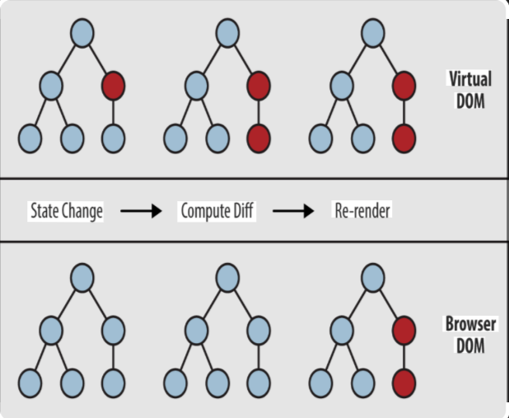

- What is Reconciliation in React?
Reconciliation in React is the process by which React efficiently updates the actual DOM (Document Object Model) to reflect changes in a component's state or props.
It's how React ensures the UI stays in sync with the underlying data while minimizing performance costs.
How it works
  - Virtual DOM: React maintains a lightweight, in-memory representation of the actual DOM called the Virtual DOM. When a component's state or props change, React first updates this Virtual DOM.
  - Compare versions: After updating the Virtual DOM, React employs a "diffing algorithm" to compare the newly generated Virtual DOM tree with the previous one. This algorithm identifies the minimal set of changes required to update the UI. It uses heuristics like:
    - Same type, same position: If elements are of the same type and in the same position, React only checks their props for changes.
    - Different types: If element types differ, React tears down the old subtree and builds a new one from scratch.
    - Keys for lists: When dealing with lists, React uses the key prop to uniquely identify elements, allowing it to efficiently track and update individual items.
  - Batching and Updating: Once the differences are identified, React batches these changes together and then applies them to the actual DOM. This batching minimizes direct manipulation of the DOM, which is a relatively expensive operation, and improves rendering performance.
  - Update the real DOM: Finally, React updates only the specific parts of the actual DOM that have been modified, avoiding costly re-renders of the entire page.

